EXP 17

**Install Virtual box/VMware Workstation with different flavors of Linux or windows OS on top of your present windows environment**

STEP 1: To create the new virtual machine

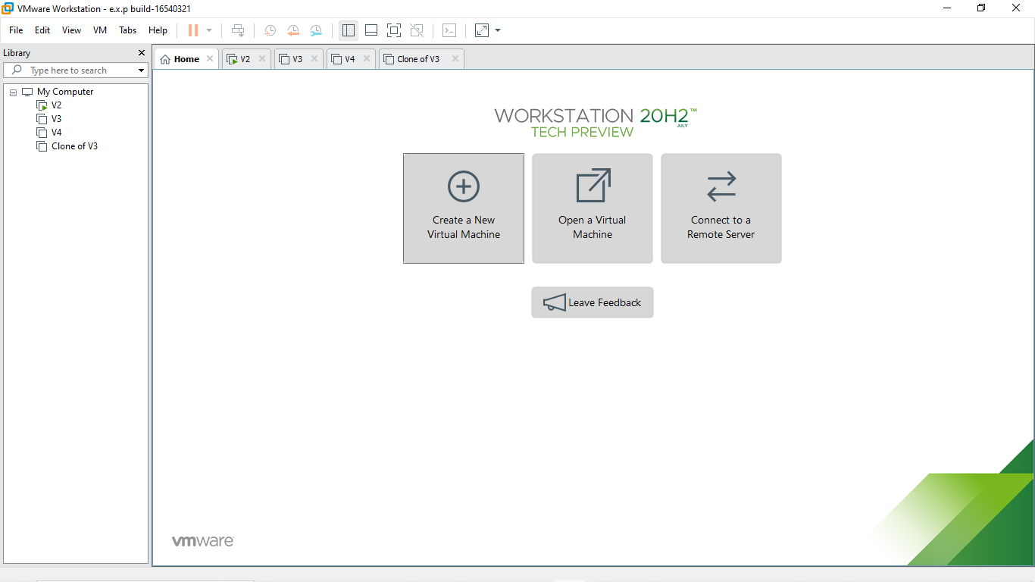

STEP 2: To install the guest operating system and browse it in the installer disc image file

R.Akash 192121091

STEP 3: Name the virtual machine

STEP 4: Give storage to the disk capacity in a single file

R.Akash 192121091

STEP 5: And the ubuntu virtual machine is created

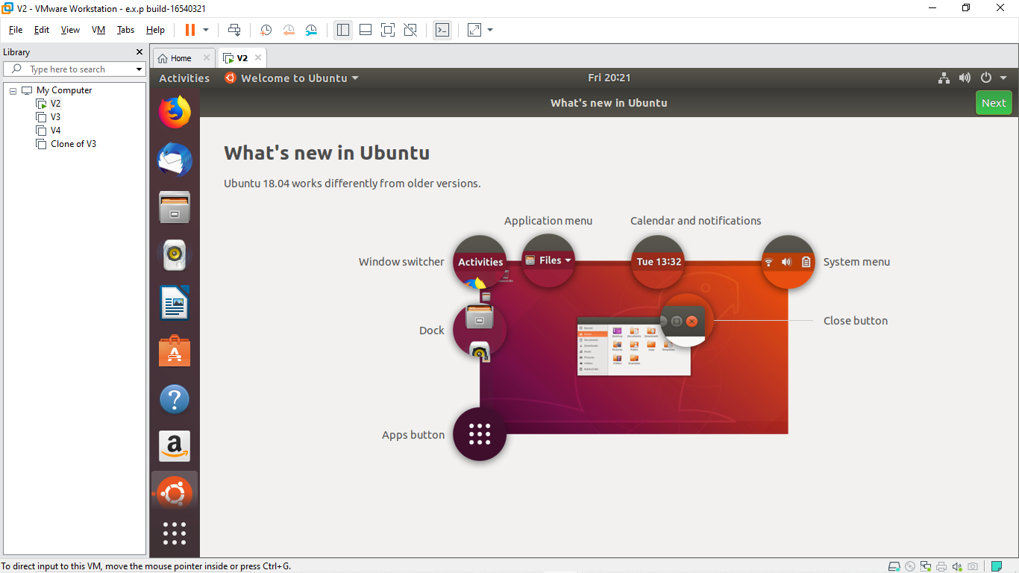

STEP 6: Download the virtual box in fire fox internet

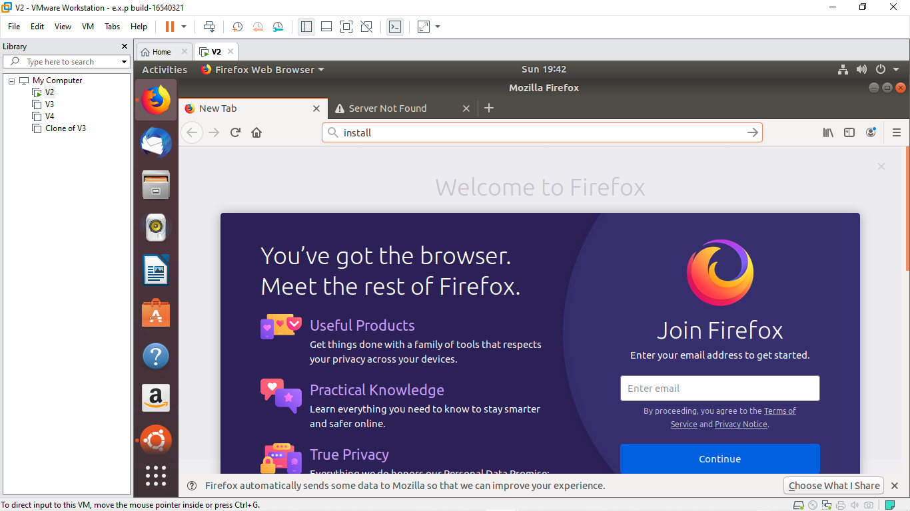

R.Akash 192121091

STEP 7: downloaded the virtual box in the ubuntu virtual machine

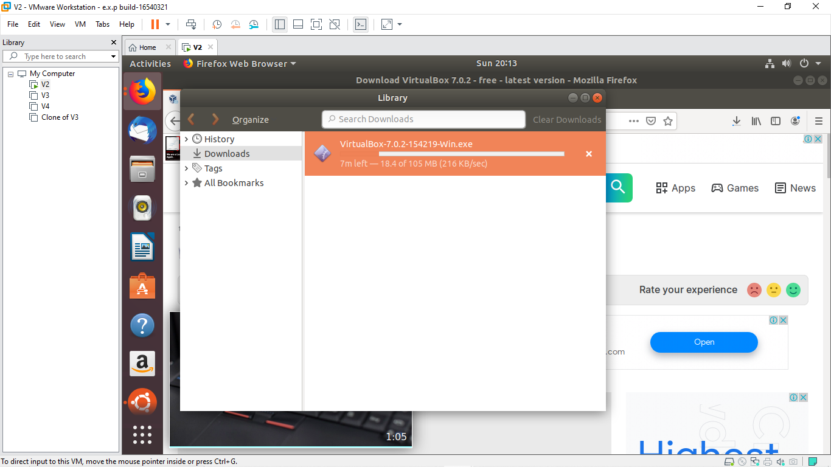

R.Akash 192121091